**CHAPTER 4**

**University of San Carlos Audio Visual Reservation and Asset Management System’s**

**Software Development**

**4.1 Requirement Specification**

This Section will describe the business flow, different interfaces, assumption and dependencies, constraint and the specific requirement of the project

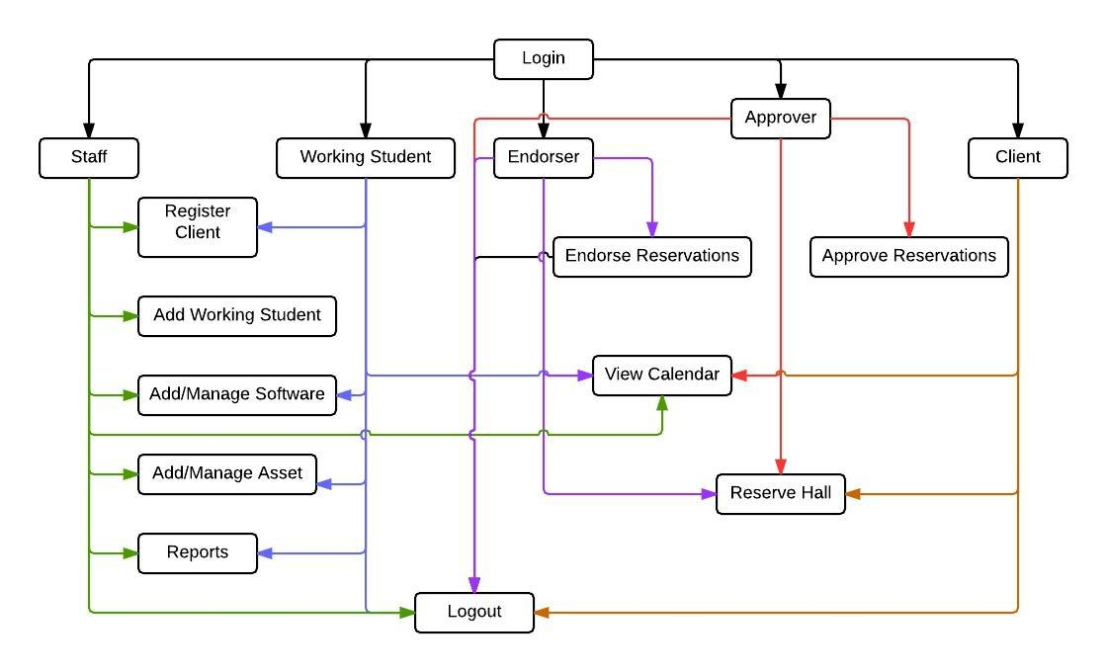 **4.1.1 Business Process Flow**

***Figure 4.1.1.1 Business Process Flow***

**4.1.2. System Interfaces**

As the developers gathered date and have seen in the business flow of the audio visual center, there are parts that can be automated.

The modules for our system are:

Login

* This module where the clients, approver, endorser, working student, and staff will input each username and password according their accounts.

Software Item

* This module has the record of each software materials found in the Audio Visual Office. It can add software materials and update the information of the materials. It can change the status of the materials if it is available or borrowed.

Asset Item

* This module has the record of assets found in the Audio Visual Office. It can add update the information of the assets.

Working Student

* This module has the record of working student found in a specific Audio Visual Office in the campus. It can add update the information of the working student.

Calendar

* This module displayed the reserved time and dates of all the halls in the university. It can be viewed weekly and monthly

Register

* This module registered different clients in the system. Client in the system can be a faculty, student or employee. The staff and working has the power to register these users.

Reservation

* This module reserved clients preferred time and date in using a hall.

Statistical Report

* This module generates the statistical data of the usage of the hall.

Endorser

* This module views the reservation form that need to be endorsed. This is where the reservation appears after submitting the form

Approver

* This module views the reservation form that need to be approved. This is where the reservation appears after it is being endorsed.

**4.1.3 User Interfaces**

The system provides login module where the staff, working student, approver, endorser, clients input their specific username and password. The staff, working student, approver, endorser, clients are different module when they logged in. The staff can access all the modules except reservation, working student can also access some modules except reservation and working student, endorser can only access the reservation, calendar and endorser module, approver can only access the reservation, calendar and approver module, clients can only access the reservation and calendar module.

**4.1.4 Hardware Interfaces**

This section covers the different hardware we have used in order for the system to work.

**Table 4.1.4.1 Hardware Interfaces**

|  |  |
| --- | --- |
| Name | Purpose |
| **Desktop Computer/ Laptop** | To access the different modules in the system |
| **Internet Connection** | In order for the system to work online |
| **Printer** | To print the statistics that is needed by the staff. |

**4.1.5 Software Interfaces**

This section covers the different software we have used so far for this system and additional plug-ins that allowed it to work.

**Table 4.1.5.1 Software Interfaces**

|  |  |  |  |
| --- | --- | --- | --- |
| Name | Version No. | Source | Purpose |
| **Xampp** | **V3.2.1** | http://sourceforge.net/projects/xampp | Interprets the scripts written in PHP and includes the SQL Database manipulation and uploading through Filezilla |
| **PHP** | **PHP 5.6.0** | http://php.net/ | All-purpose programming |
| **Bootstrap** | **V3.2.0** | http://getbootstrap.com/ | To apply simple design and interior security checks(e.g Pattern) |
| **Google Chrome** | **Version 37.0.2062.120** | https://www.google.com.ph/chrome/browser/ | For research purposes and used to adjust display for our website. |
| **Code Igniter** | **V2.2.0** | http://www.codeigniter.com/ | Used this php framework for efficient coding. |

**4.1.6 Communication Interfaces**

This project can be shown in the library system since the Audio Visual Center is under the library system and it can be access either outside or inside the university. The head and staff of each Audio Visual Center have an access with the system in order to manage the system. Another is the director of library system also needs to have an access so that he can view the reservation and statistics of the reservation system for some reasons. The director of the library system can’t edit and add software materials or assets. The director can only reserve a hall and reset the entire datum in the database

**4.1.7 User characteristics**

There are five user rights for this system namely the Staff, Working Student, Approver, Endorser and the Client. The user side has all the rights of the system because he is the on managing it. The Working Student side has almost all the right except adding the working student. The approver can only approve reservations, view the availability and reserve hall. The endorser can only endorse reservations, view the availability and reserve hall. The client can only view the availability and reserve halls.

**4.1.8 Assumptions and dependencies**

In implementing the system, develops must know some of the assumptions and dependencies of the system to avoid problems in implementing it.

**Assumptions:**

* The clients should be faculty, student or employee in the University of San Carlos
* The users should have a sufficient knowledge of computers
* There must have an internet connection in accessing the system.

**Dependencies:**

* The different users will be able to input there correct username and password in using the different plug-ins of the system.

**4.1.10 Specific Requirements**

**4.1.10.1 Functional Requirements**

A. Login

**Table 4.1.10.1.1 Login**

|  |  |  |  |
| --- | --- | --- | --- |
| **Requirement ID** | **Descriptiion** | **Priority** | **Approved/** |
|  |  |  |  |
|  |  |  |  |

**4.1.10.2 Performance Requirements**

**4.1.10.3 Software System attributes (Reliability, Availability, Security, Main1tainability, Portability) if exists if none then ignore**

**4.2. Design Specification**

**4.2.1 Component Diagram (a UML diagram)**

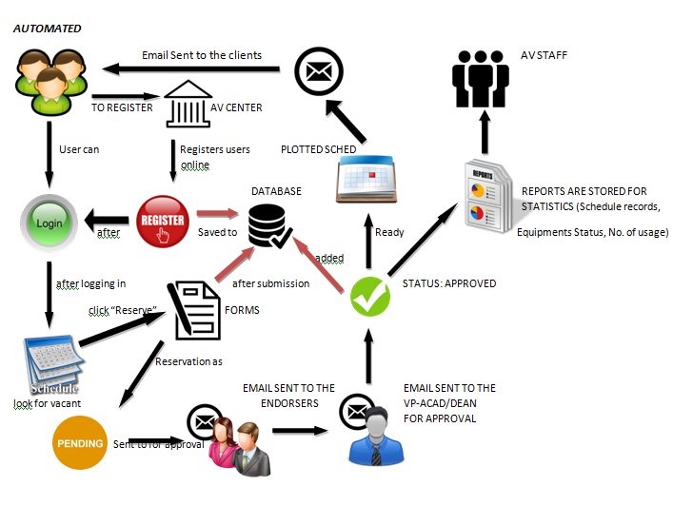

**High-level Use Case(a U**

***Figure 4.2.1 Component Diagram***

**4.2.2 High-level Use Case (a UML diagram)**

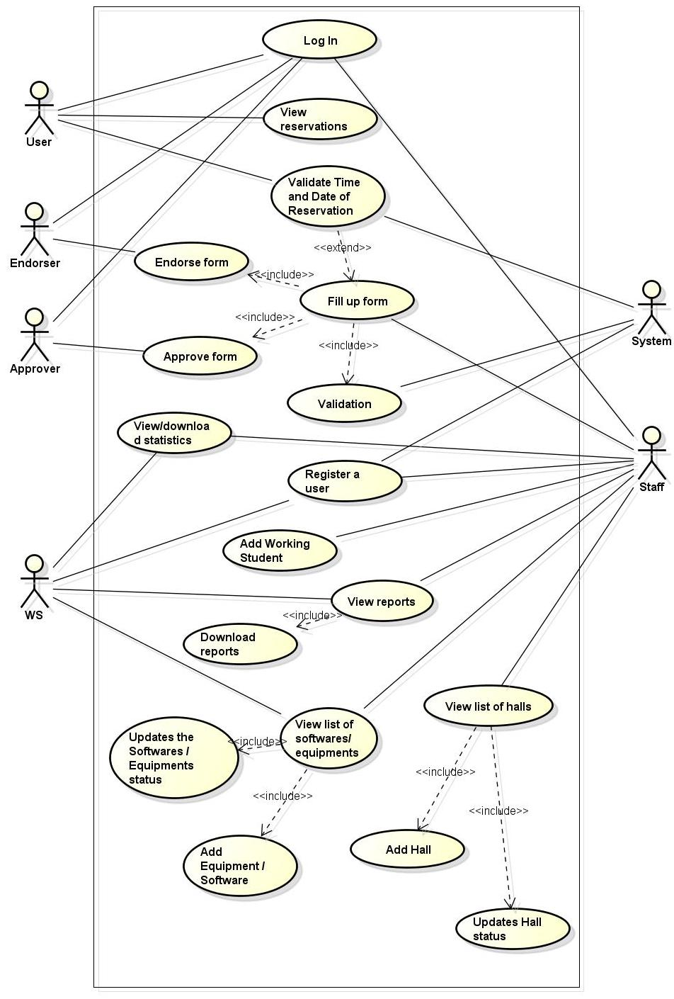

***Figure 4.2.2 High-level Use Case Diagram***

**4.2.3 Entity Relationship Diagram**

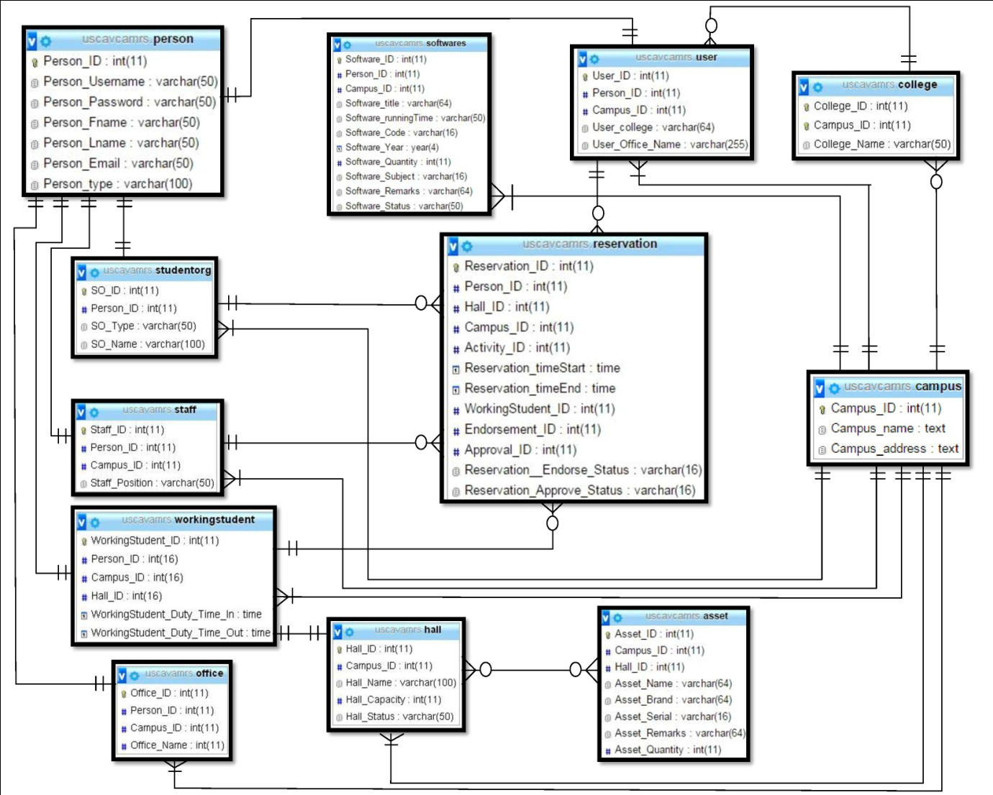

***Figure 4.2.3 Entity Relationship Diagram***

**4.3 Testing and Evaluation**